1. 103.238.100.229

Nmap -sT

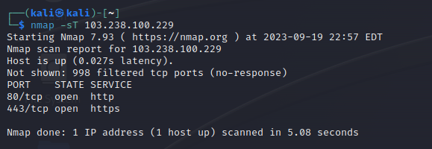

sudo Nmap -sS

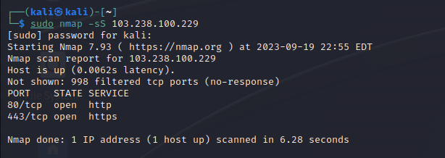

1. **20.40.0.168**

Nmap -sT

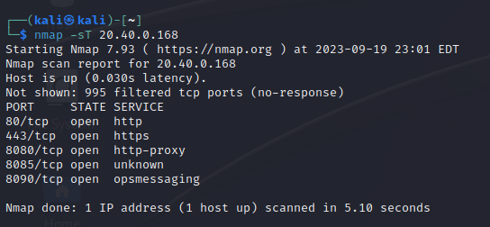

Sudo nmap -sS

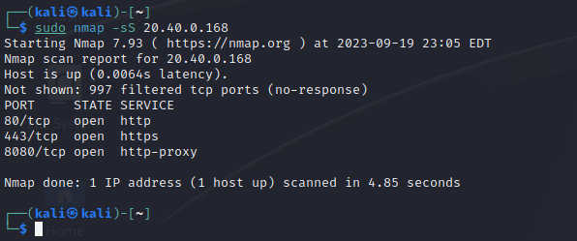

1. **172.105.154.45**

Nmap -sT

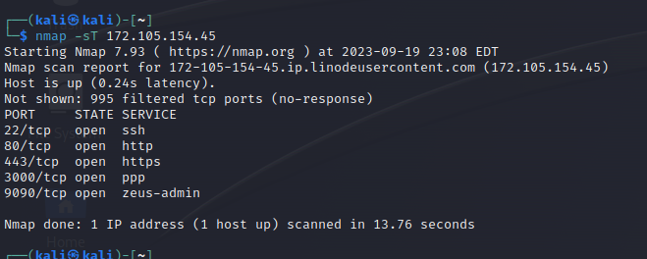

Sudo nmap -sS

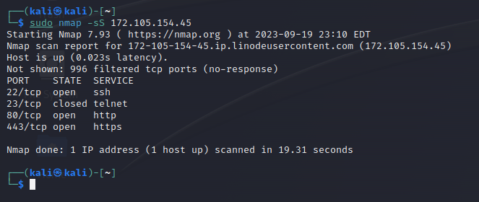

1. **159.65.150.98**

Nmap -sT

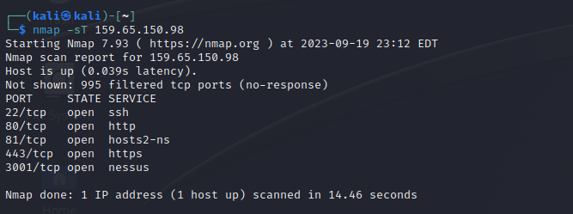

Sudo nmap -sS

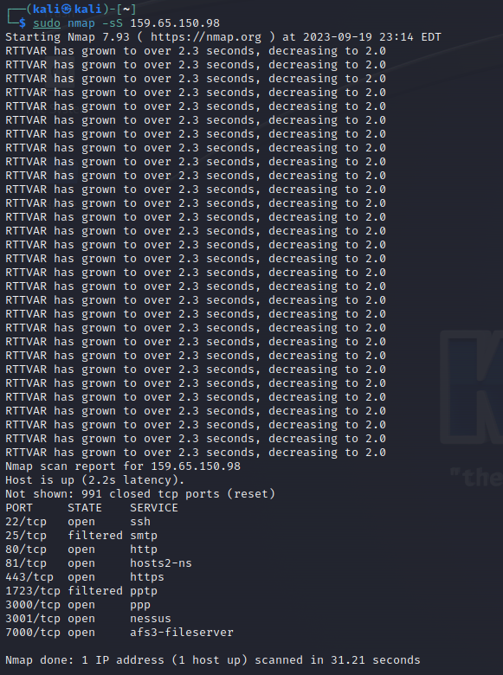

5.**43.204.127.142**

Nmap - sT

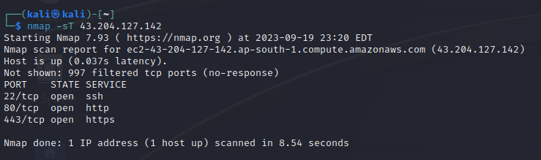

Sudo nmap -sS

